The basics of garbage collection
The garbage collector first performs a task called marking. The garbage collector traverses the application graph, starting with the root objects; those are objects that are represented by all active stack frames and all the static variables loaded into the system. Each object the garbage collector meets is marked as being used, and will not be deleted in the sweeping stage.
The sweeping stage is where the deletion of objects take place. There are many ways to delete an object: The traditional C way was to mark the space as free, and let the allocator methods use complex data structures to search the memory for the required free space. This was later improved by providing a defragmenting system which compacted memory by moving objects closer to each other, removing any fragments of free space and therefore allowing allocation to be much faster:
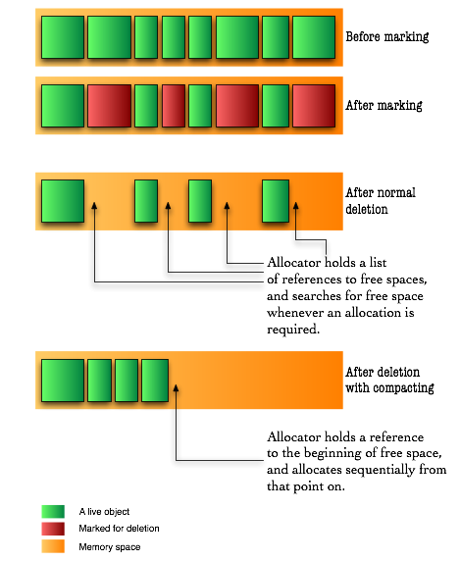
For the last trick to be possible a new idea was introduced in garbage collected languages: even though objects are represented by references, much like in C, they don’t really reference their real memory location. Instead, they refer to a location in a dictionary which keeps track of where the object is at any moment.
Fortunately for us - but unfortunately for these garbage collection algorithms - our servers and personal computers got faster (and multiple) processors and bigger memory capacities. Compacting memory areas this large often was very taxing on the application, especially considering that when doing that, the whole application had to freeze due to the changes in the virtual memory map. Fortunately for us though, some smart people improved those algorithms in three ways: concurrency, parallelization and generational collection.

Generational garbage collection
In any application, objects could be categorized according to their life-line. Some objects are short-lived, such as most local variables, and some are long-lived such as the backbone of the application. The thought about generational garbage collection was made possible with the understanding that in an application’s lifetime, most instantiated objects are short-lived, and that there are few connections between long-lived objects to short-lived objects.
In order to take advantage of this information, the memory space is divided to two sections:young generation and old generation. In Java, the long-lived objects are further divided again to permanent objects and old generation objects. Permanent objects are usually objects the Java VM itself created for caching like code, reflection information etc. Old generation objects are objects that survived a few collections in the young generation area.
Since we know that objects in the young generation memory space become garbage early, we collect that area frequently while leaving the old generation’s memory space to be collected in larger intervals. The young generation memory space is much smaller, thus having shorter collection times.
An additional advantage to the knowledge that objects die quickly in this area, we can also skip the compacting step and do something else called copying. This means that instead of seeking free areas (by seeking the areas marked as unused after the marking step), we copy the live objects from one young generation area to another young generation area. The originating area is called the From area, and the target area is called the To area, and after the copying is completed the roles switch: the From becomes the To, and the To becomes the From.
In addition, the Java VM splits the young generation to three areas, by adding an area called Eden which is where all objects are allocated into. To my understanding this is done to make allocation faster by always having the allocator reference to the beginning of Eden after a collection.
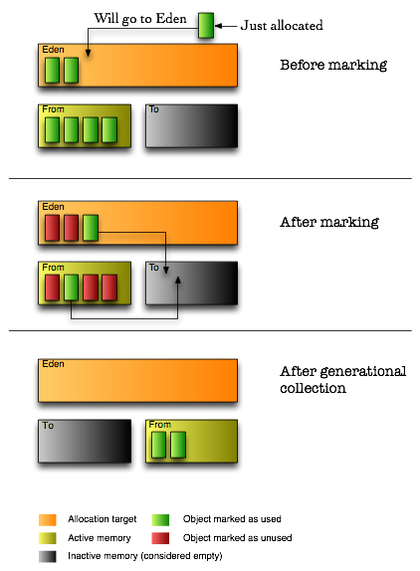
By using the copying method, garbage collection achieves defragmentation without seeking for dead memory blocks. However, this method proves itself to be more efficient in areas where most objects are garbage, so it is not a good approach to take on the old generation memory area. Indeed, that area is still collected using the compacting algorithm - but now, thanks to the separation of young and old generations, it is done in much larger intervals.

Mark-and-Sweep Garbage Collection
This section presents the mark-and-sweep garbage collection algorithm. The mark-and-sweep algorithm was the first garbage collection algorithm to be developed that is able to reclaim cyclic data structures.Variations of the mark-and-sweep algorithm continue to be among the most commonly used garbage collection techniques.
When using mark-and-sweep, unreferenced objects are not reclaimed immediately. Instead, garbage is allowed to accumulate until all available memory has been exhausted. When that happens, the execution of the program is suspended temporarily while the mark-and-sweep algorithm collects all the garbage. Once all unreferenced objects have been reclaimed, the normal execution of the program can resume.
The mark-and-sweep algorithm is called a tracing garbage collector because is traces out the entire collection of objects that are directly or indirectly accessible by the program. The objects that a program can access directly are those objects which are referenced by local variables on the processor stack as well as by any static variables that refer to objects. In the context of garbage collection, these variables are called the roots . An object is indirectly accessible if it is referenced by a field in some other (directly or indirectly) accessible object. An accessible object is said to be live . Conversely, an object which is not live is garbage.
The mark-and-sweep algorithm consists of two phases: In the first phase, it finds and marks all accessible objects. The first phase is called the mark phase. In the second phase, the garbage collection algorithm scans through the heap and reclaims all the unmarked objects. The second phase is called the sweep phase. The algorithm can be expressed as follows:
for each root variable r
mark (r);
sweep ();
In order to distinguish the live objects from garbage, we record the state of an object in each object. That is, we add a special boolean field to each object called, say, marked. By default, all objects are unmarked when they are created. Thus, the marked field is initially false.
An object p and all the objects indirectly accessible from p can be marked by using the following recursive mark method:
void mark (Object p)

if (!p.marked)

p.marked = true;
for each Object q referenced by p
mark (q);

Notice that this recursive mark algorithm does nothing when it encounters an object that has already been marked. Consequently, the algorithm is guaranteed to terminate. And it terminates only when all accessible objects have been marked.
In its second phase, the mark-and-sweep algorithm scans through all the objects in the heap, in order to locate all the unmarked objects. The storage allocated to the unmarked objects is reclaimed during the scan. At the same time, the marked field on every live object is set back to false in preparation for the next invocation of the mark-and-sweep garbage collection algorithm:
void sweep ()

for each Object p in the heap

if (p.marked)
p.marked = false
else
heap.release (p);

Figure illustrates the operation of the mark-and-sweep garbage collection algorithm. Figure (a) shows the conditions before garbage collection begins. In this example, there is a single root variable. Figure (b) shows the effect of the mark phase of the algorithm. At this point, all live objects have been marked. Finally, Figure (c) shows the objects left after the sweep phase has been completed. Only live objects remain in memory and the marked fields have all been set to false again.
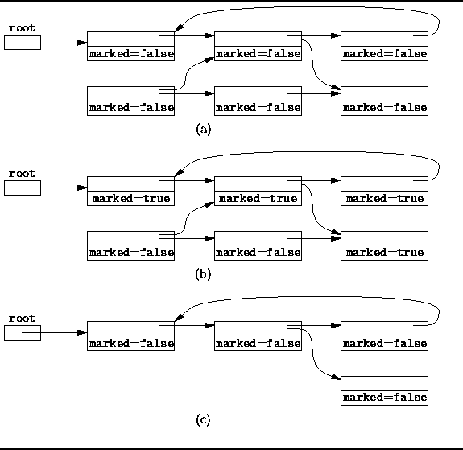
Figure: Mark-and-sweep garbage collection.
Because the mark-and-sweep garbage collection algorithm traces out the set of objects accessible from the roots, it is able to correctly identify and collect garbage even in the presence of reference cycles. This is the main advantage of mark-and-sweep over the reference counting technique presented in the preceding section. A secondary benefit of the mark-and-sweep approach is that the normal manipulations of reference variables incurs no overhead.
The main disadvantage of the mark-and-sweep approach is the fact that that normal program execution is suspended while the garbage collection algorithm runs. In particular, this can be a problem in a program that interacts with a human user or that must satisfy real-time execution constraints. For example, an interactive application that uses mark-and-sweep garbage collection becomes unresponsive periodically.

Mark-and-Compact Garbage Collection
The mark-and-sweep algorithm described in Section has the unfortunate tendency to fragment the heap. The stop-and-copy algorithm described in Section avoids fragmentation at the expense of doubling the size of the heap. This section describes the mark-and-compact approach to garbage collection which eliminates fragmentation without the space penalty of stop-and-copy.
The mark-and-compact algorithm consists of two phases: In the first phase, it finds and marks all live objects. The first phase is called the mark phase. In the second phase, the garbage collection algorithm compacts the heap by moving all the live objects into contiguous memory locations. The second phase is called the compaction phase. The algorithm can be expressed as follows:
for each root variable r
mark (r);
compact ();

